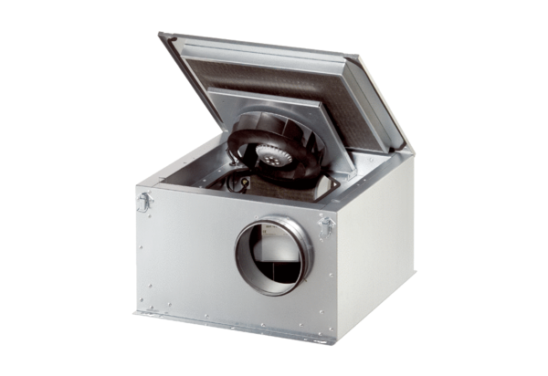Sound-insulated ventilation box ESR 25 ECPacking unit: 1 pieceRange: E
Article number: 0080.0087Manufacturer: MAICO

