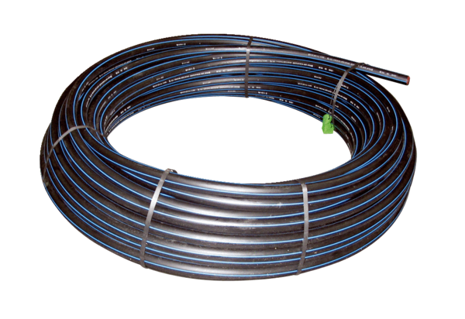Pressure duct EW-DPacking unit: 100 mRange: K
Article number: 0059.0200Manufacturer: MAICO

