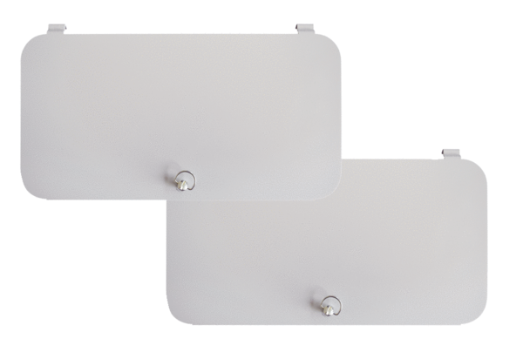Filter locking cover WS-FVA 300Packing unit: 2 piecesRange: K
Article number: 0092.0575Manufacturer: MAICO

