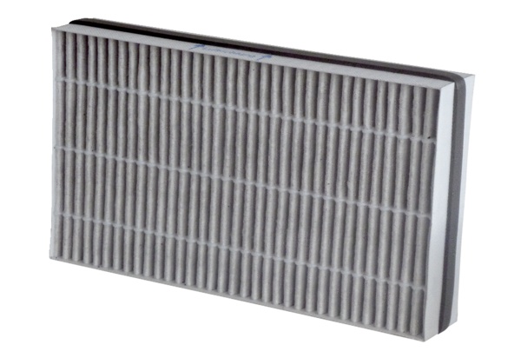Air filter, replacement WSF-AKF 320/470Packing unit: 1 pieceRange: K
Article number: 0092.0563Manufacturer: MAICO

