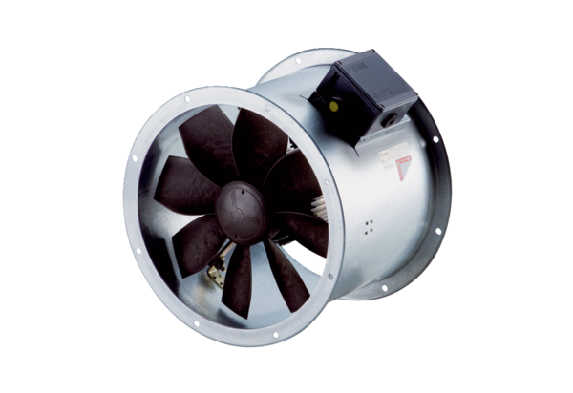Axial duct fan DZR 50/6 B Ex ePacking unit: 1 pieceRange: C
Article number: 0086.0713Manufacturer: MAICO

