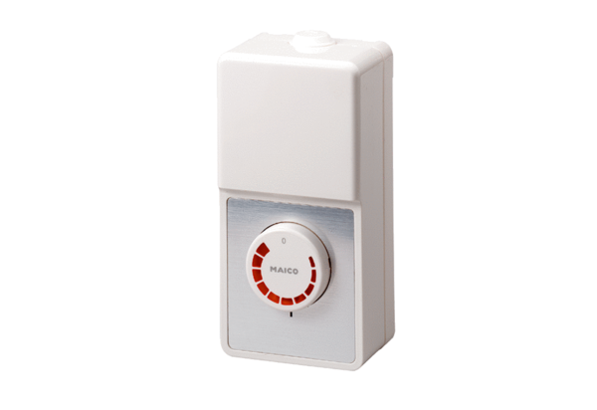Speed controller ST 5Packing unit: 1 pieceRange: C
Article number: 0157.0812Manufacturer: MAICO

