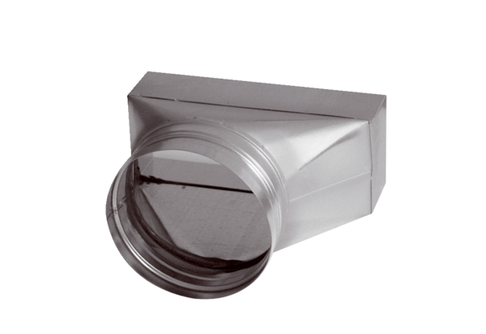Intermediate piece, asymmetric USAN80/200/80Packing unit: 1 pieceRange: K
Article number: 0055.0670Manufacturer: MAICO

