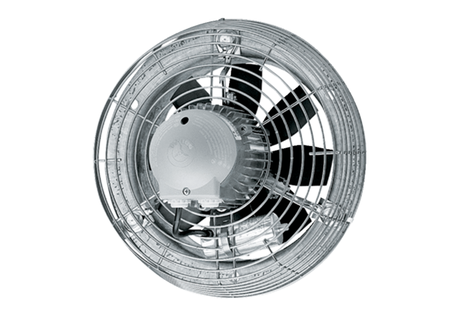Axial wall fan DZS 30/4 BPacking unit: 1 pieceRange: C
Article number: 0094.0015Manufacturer: MAICO

