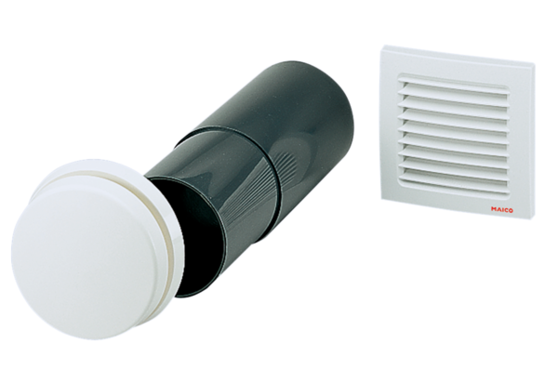Outside air opening ALD 10 TPacking unit: 1 pieceRange: B
Article number: 0152.0055Manufacturer: MAICO

