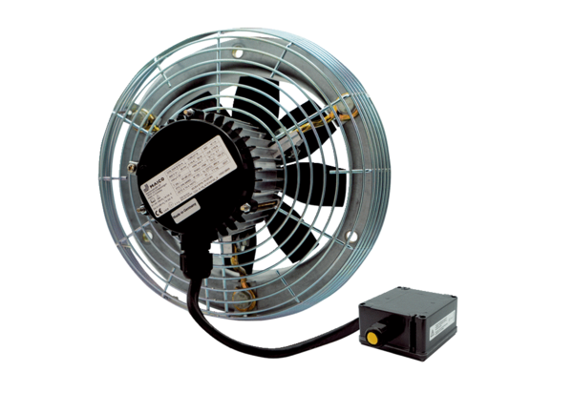Axial wall fan DZS 30/2 B Ex ePacking unit: 1 pieceRange: C
Article number: 0094.0122Manufacturer: MAICO

