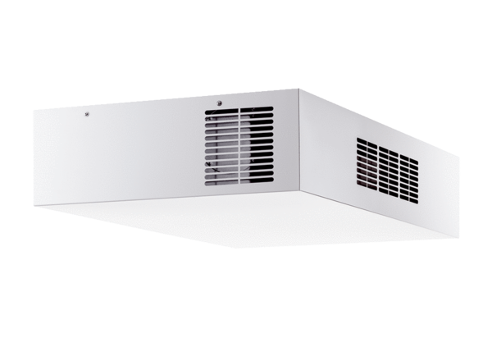Decentralised ventilation unit with heat recovery Trio QD-ALPacking unit: 1 pieceRange: K
Article number: 0095.0120Manufacturer: MAICO

