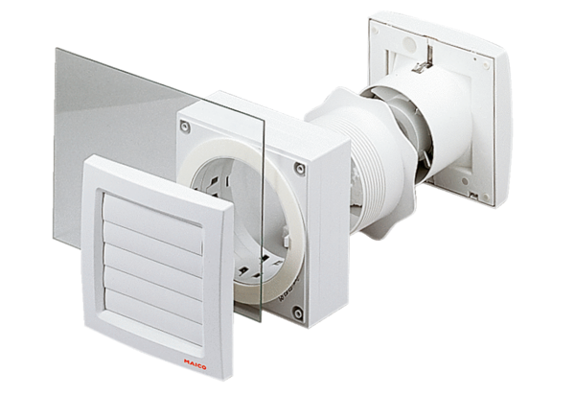Window installation kit FE 100 APPacking unit: 1 pieceRange: A
Article number: 0093.1024Manufacturer: MAICO

