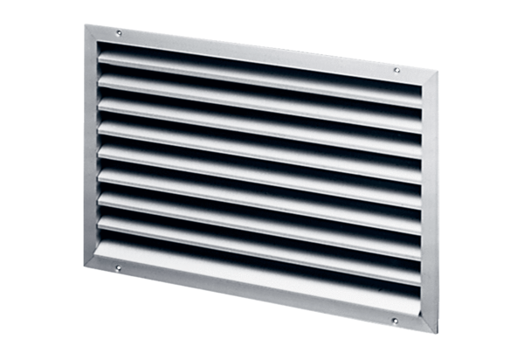External grille LAP 50Packing unit: 1 pieceRange: D
Article number: 0151.0312Manufacturer: MAICO

