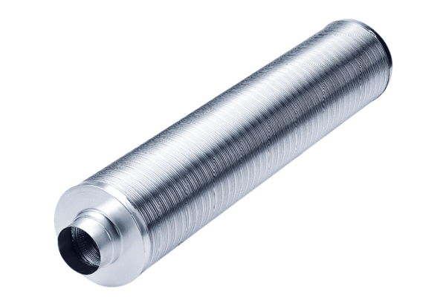Tubular sound absorber RSR 18/50Packing unit: 1 pieceRange: C
Article number: 0092.0325Manufacturer: MAICO

