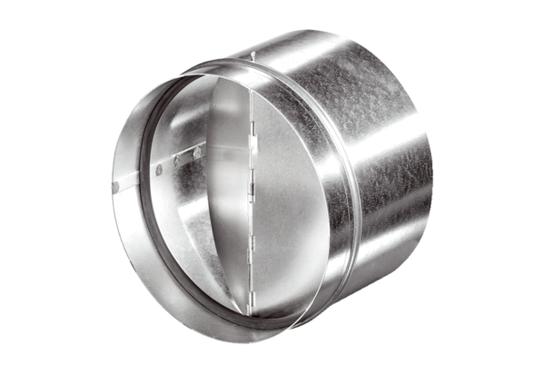Automatic backflow preventer AVM 25Packing unit: 1 pieceRange: C
Article number: 0093.0007Manufacturer: MAICO

