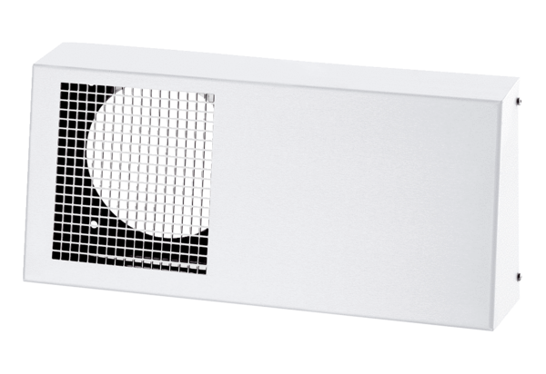Combi-wall connections Duo KWS WPacking unit: 1 pieceRange: K
Article number: 0093.1441Manufacturer: MAICO

