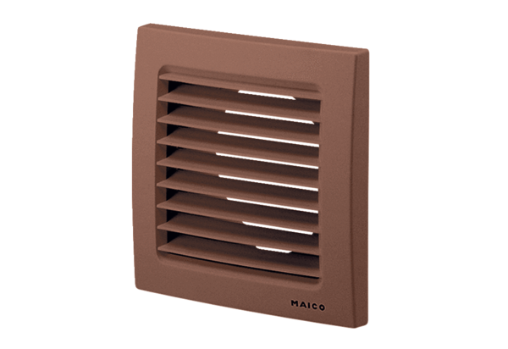External grille SG 100 BPacking unit: 1 pieceRange: A
Article number: 0059.0958Manufacturer: MAICO

