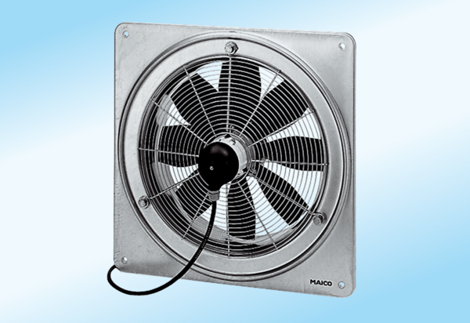Axial wall fan DZQ 30/4 A-ExPacking unit: 1 pieceRange: C
Article number: 0083.0766Manufacturer: MAICO

