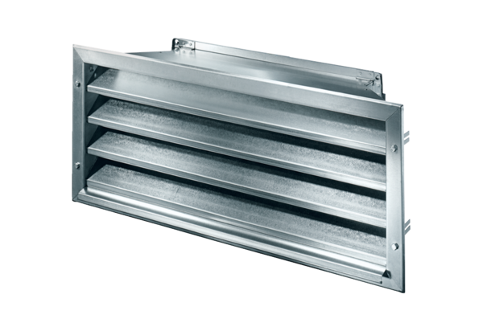External grille LZP-R 22Packing unit: 1 pieceRange: D
Article number: 0151.0381Manufacturer: MAICO

