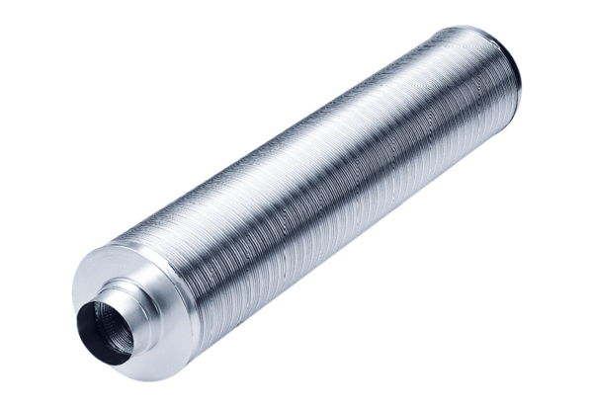Tubular sound absorber RSR 8/50Packing unit: 1 pieceRange: C
Article number: 0092.0320Manufacturer: MAICO

