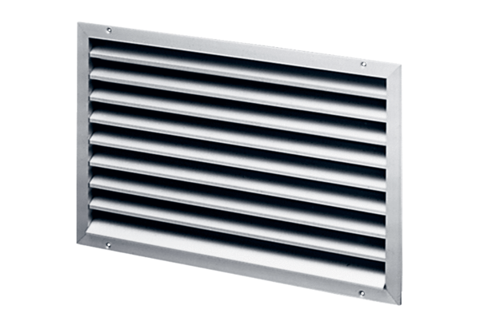External grille LAP 25Packing unit: 1 pieceRange: D
Article number: 0151.0251Manufacturer: MAICO

