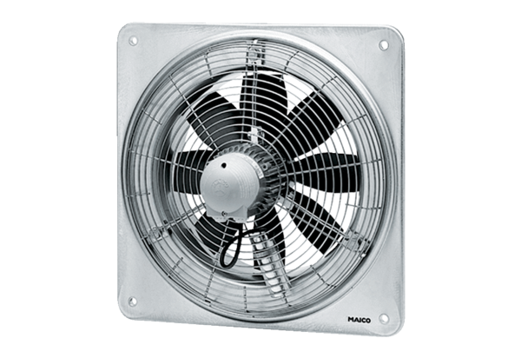Axial wall fan DZQ 30/4 BPacking unit: 1 pieceRange: C
Article number: 0083.0120Manufacturer: MAICO

