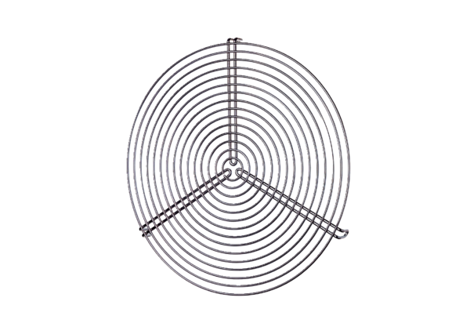Protective grille SGR 31Packing unit: 1 pieceRange: C
Article number: 0150.0128Manufacturer: MAICO

