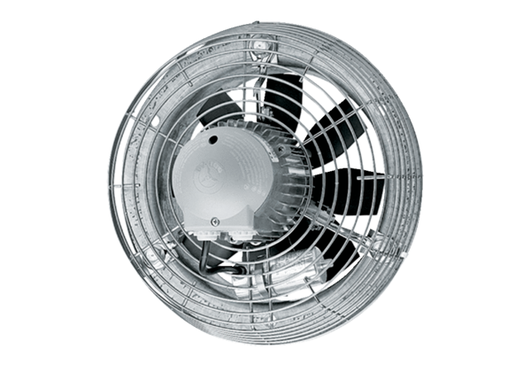Axial wall fan EZS 25/2 BPacking unit: 1 pieceRange: C
Article number: 0094.0001Manufacturer: MAICO

