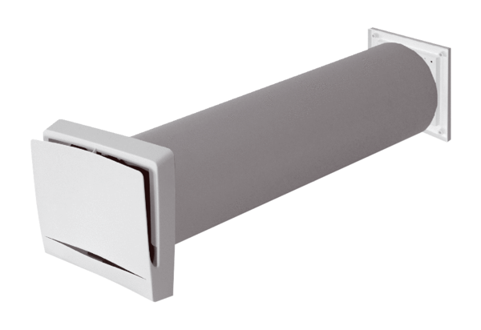Outside air opening ALD 12 SVAPacking unit: 1 pieceRange: B
Article number: 0152.0053Manufacturer: MAICO

