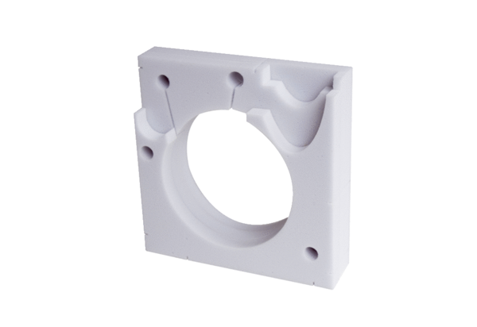Sound-absorbing element ER-SE UPPacking unit: 1 pieceRange: B
Article number: 0192.0678Manufacturer: MAICO

