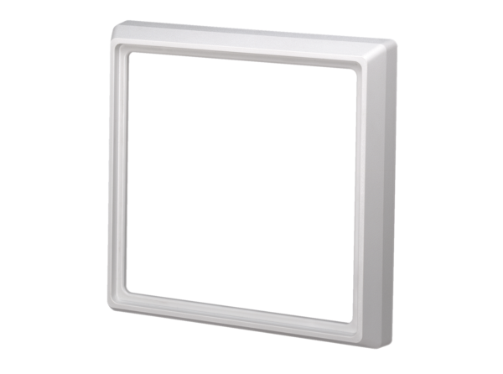Masking frame ER-ARPacking unit: 1 pieceRange: B
Article number: 0059.0899Manufacturer: MAICO

