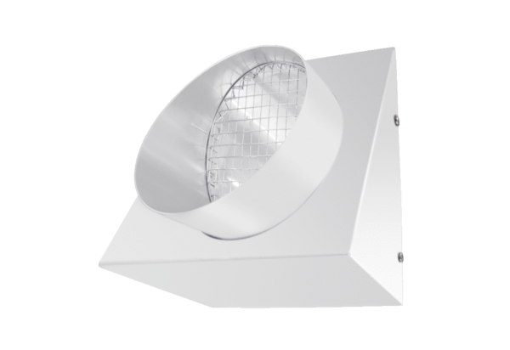Outgoing air wall connection KW-FL 16WPacking unit: 1 pieceRange: K
Article number: 0152.0080Manufacturer: MAICO

