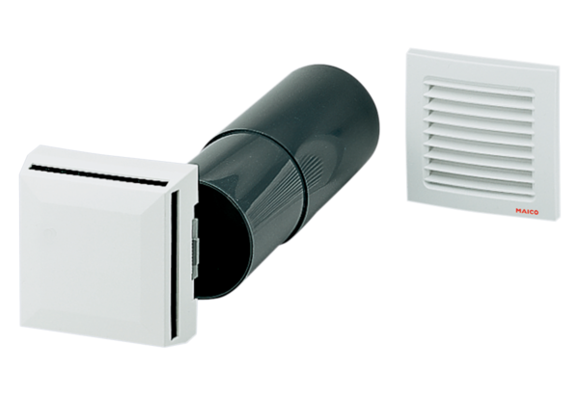Outside air opening ALD 10Packing unit: 1 pieceRange: B
Article number: 0152.0054Manufacturer: MAICO

