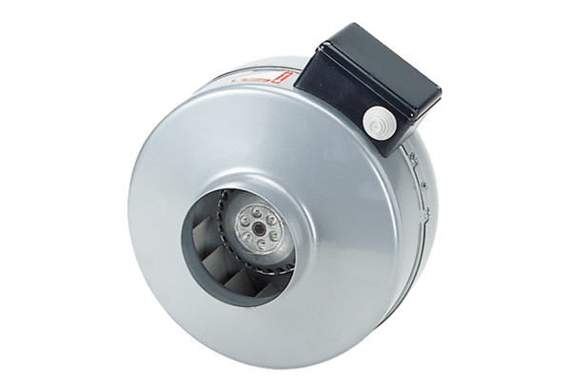Centrifugal duct fan ERR 10/1 SPacking unit: 1 pieceRange: C
Article number: 0080.0271Manufacturer: MAICO

