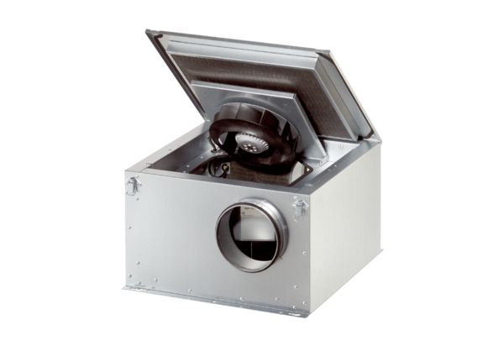Sound-insulated ventilation box ESR 20-2 ECPacking unit: 1 pieceRange: E
Article number: 0080.0712Manufacturer: MAICO

