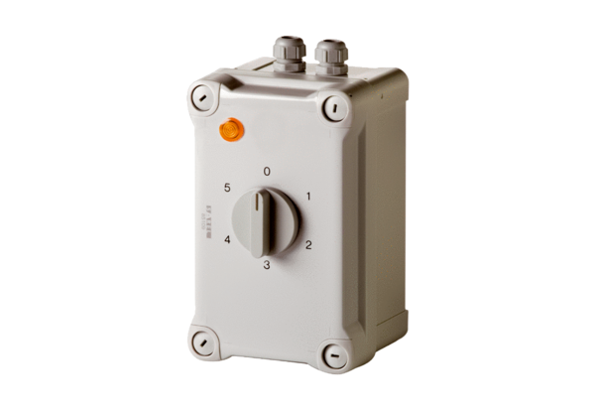5-step transformer TRE 0,6-1Packing unit: 1 pieceRange: C
Article number: 0157.0347Manufacturer: MAICO

