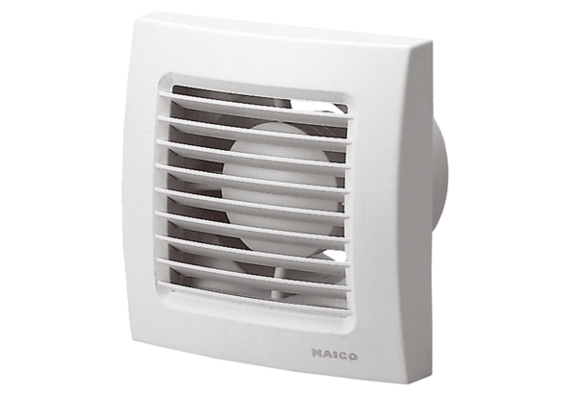Small room fan ECA 150Packing unit: 1 pieceRange: A
Article number: 0084.0012Manufacturer: MAICO

