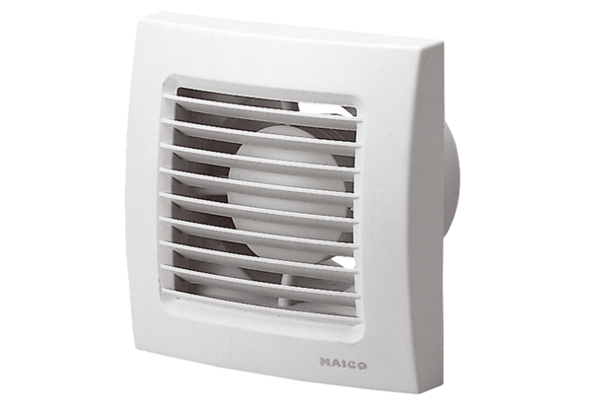Small room fan ECA 120 FPacking unit: 1 pieceRange: A
Article number: 0084.0008Manufacturer: MAICO

