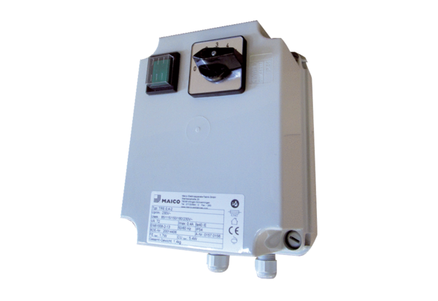5-step transformer TRE 1,6-2Packing unit: 1 pieceRange: C
Article number: 0157.0158Manufacturer: MAICO

