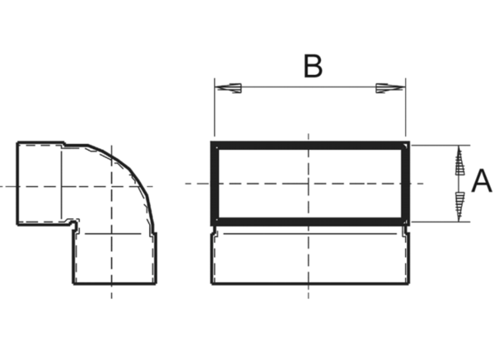90° channel elbows, short, vertical KB90KV/80/100Packing unit: 1 pieceRange: K
Article number: 0055.0597Manufacturer: MAICO

