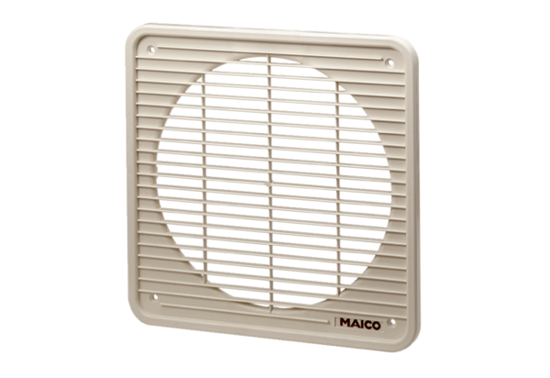Internal grille IG 25Packing unit: 1 pieceRange: C
Article number: 0059.0172Manufacturer: MAICO

