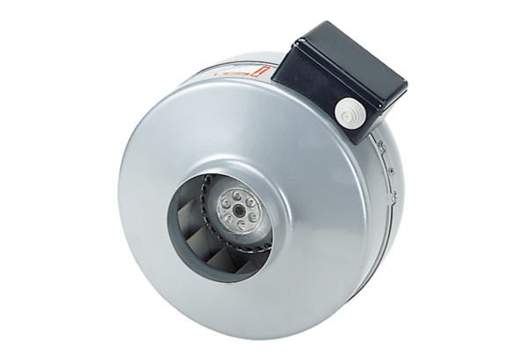Centrifugal duct fan ERR 20/1Packing unit: 1 pieceRange: C
Article number: 0080.0275Manufacturer: MAICO

