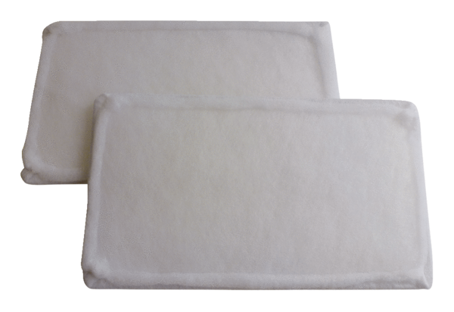Air filter, replacement WRF 300 DCPacking unit: 2 piecesRange: K
Article number: 0093.0023Manufacturer: MAICO

