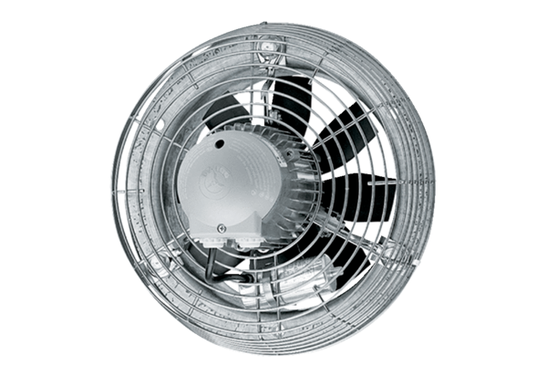Axial wall fan DZS 50/6 BPacking unit: 1 pieceRange: C
Article number: 0094.0027Manufacturer: MAICO

