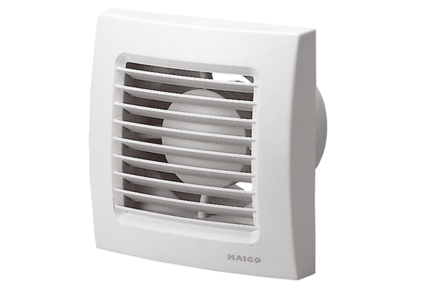Small room fan ECA 100 IPacking unit: 1 pieceRange: A
Article number: 0084.0038Manufacturer: MAICO

