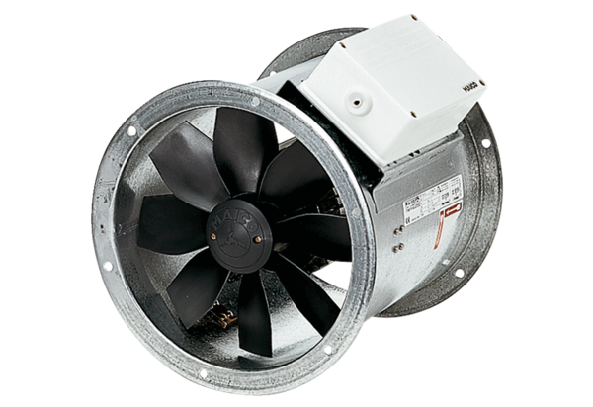Axial duct fan DZR 45/4 BPacking unit: 1 pieceRange: C
Article number: 0086.0033Manufacturer: MAICO

