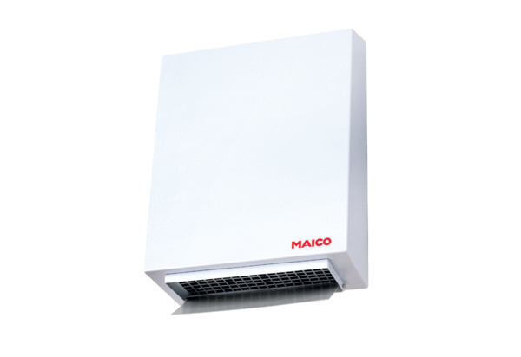Centrifugal external wall fan AWV 10Packing unit: 1 pieceRange: C
Article number: 0080.0994Manufacturer: MAICO

