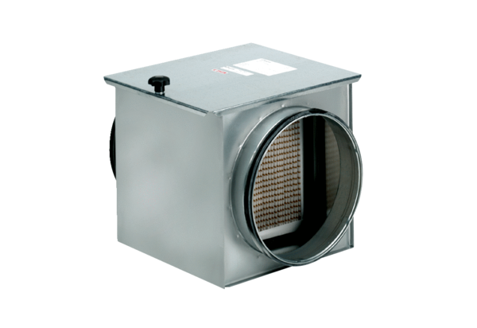Air filter TFE 15-7Packing unit: 1 pieceRange: C
Article number: 0149.0051Manufacturer: MAICO

