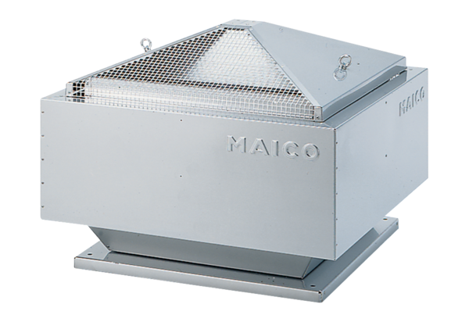Centrifugal roof fan ERD 31/4 BPacking unit: 1 pieceRange: C
Article number: 0087.0004Manufacturer: MAICO

