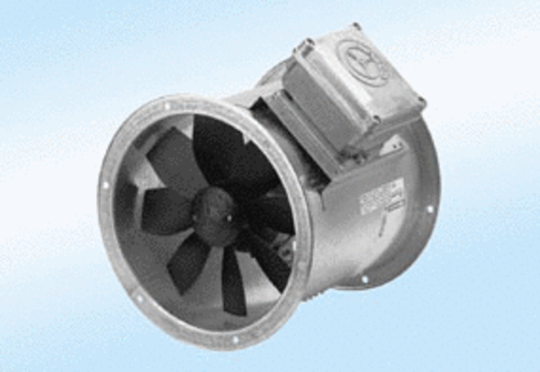Axial duct fan DZR 30/4 A-ExPacking unit: 1 pieceRange: C
Article number: 0086.0766Manufacturer: MAICO

