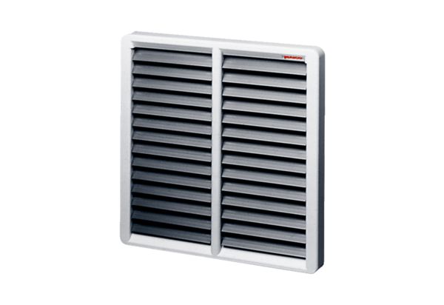Shutter AS 35Packing unit: 1 pieceRange: C
Article number: 0151.0333Manufacturer: MAICO

