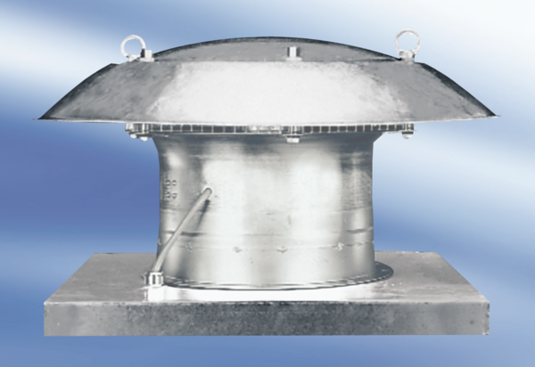Axial roof fan DZD25-2APacking unit: 1 pieceRange:
Article number: 0087.0413Manufacturer: MAICO

