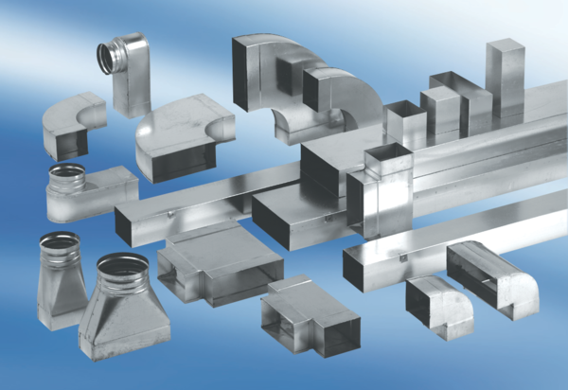40 mm channel sound absorbers with lining and attenuating linging KSDA80100230Packing unit: 1 pieceRange: K
Article number: 0092.0472Manufacturer: MAICO

