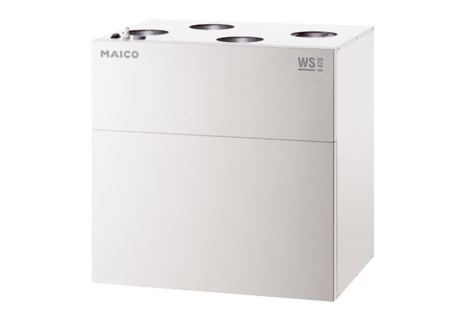Centralised ventilation unit WS 470 BETPacking unit: 1 pieceRange: K
Article number: 0095.0233Manufacturer: MAICO

